Graph Neural Network–Driven Virtual Screening of FDA-Approved Drugs Targeting Pks13 in Mycobacterium tuberculosis
Vineet Diwakar⁺, Anju Sharma⁺, Prabha Garg*
Department of Pharmacoinformatics, National Institute of Pharmaceutical Education and
Research, S. A. S. Nagar, Punjab, India-160062
⁺Shared First Authorship
*Corresponding author: prabhagarg@niper.ac.in; gargprabha@yahoo.com

Supplementary Figures
Figure S1. Area under receiver operating curve (ROC) and precision-recall curve (PRC) for DNN model trained using numeric encoding

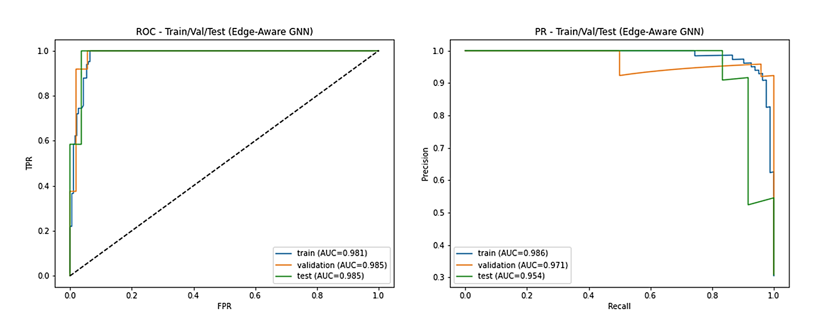
Figure S2. Area under receiver operating curve (ROC) and precision-recall curve (PRC) for GNN model trained using graph encoding

Figure S3. RMSD and Rg plot of Ligands (Co-crystallized, Conivaptan, and Pantoprazole), interaction during 300 ns simulation run

Figure S4. The SASA graph of the binding site Pks13 of Mtb in Complex with the co-crystallized and conivaptan and pantoprazole top hits

